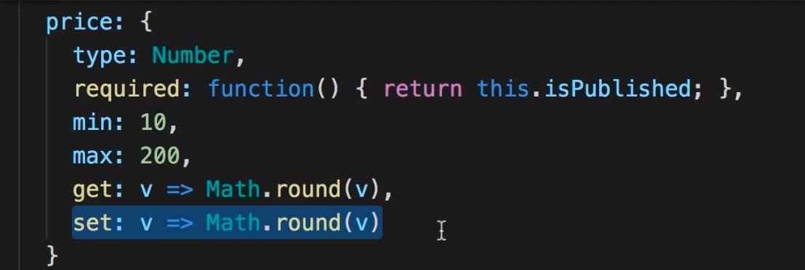

This is how we can give custom validations in schema   
get : v=> Math.round(v) it’s means when we are getting the value from data base it will return as a int means after rounding off

Same as   
set:v=> Math.round(v)   
it means when we are pushing the value in database it will go as a int

Like user input 15.6 but in our database it will save as 16

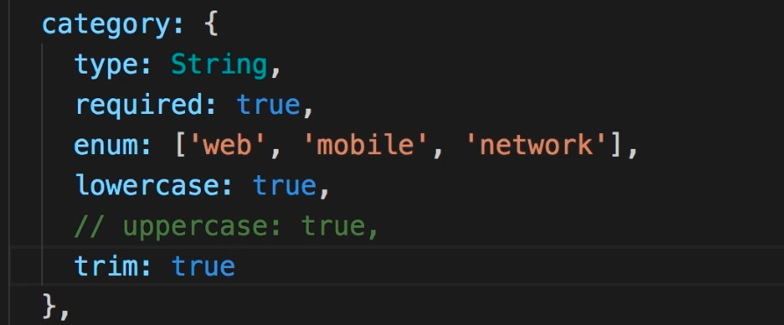

These are also additional propertites which we can give to our string

Lowercase : true ka matalb h ki jo bhi string aaye wo lowercase mai hi save hogi database mai

Same as uppercase

Read this

Like If a user give string as “PankAj” but it will save as Pankaj because we are using lowercase: true

